**ASSIGNMENT 6 BY LAVIN CHOUDHARY**

**Q1:-** Create a Storage account and explore all the option while creating.

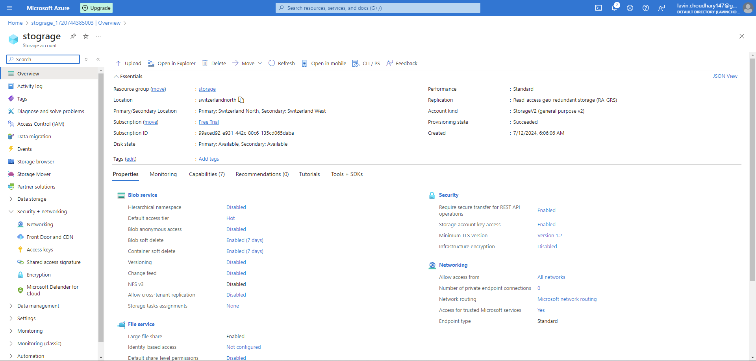

**Q2:-** Upload and Access the blob.

UPLOADING…

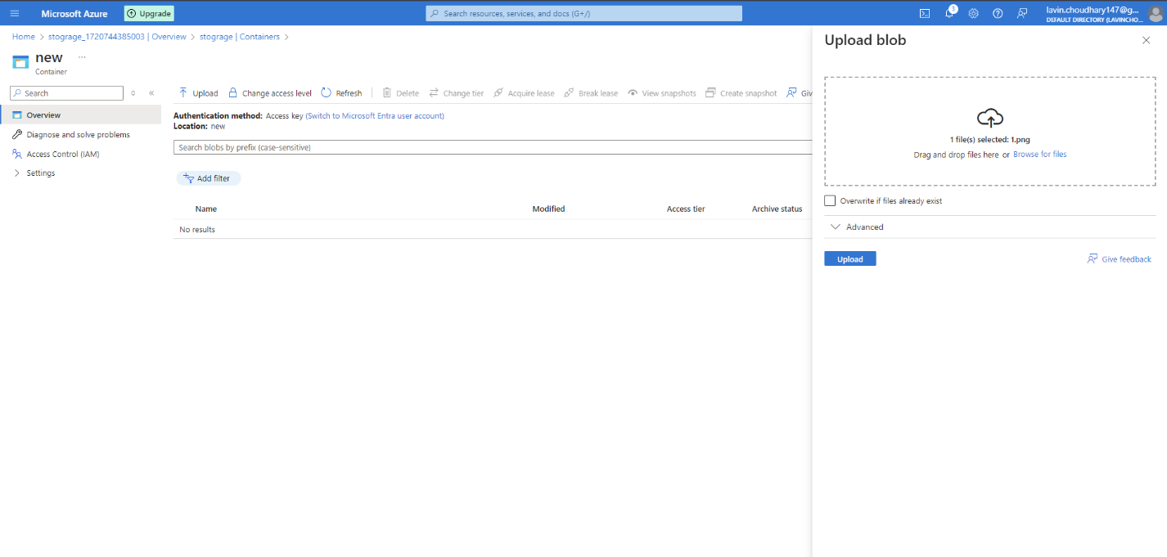

ACCESSING THE BLOB…

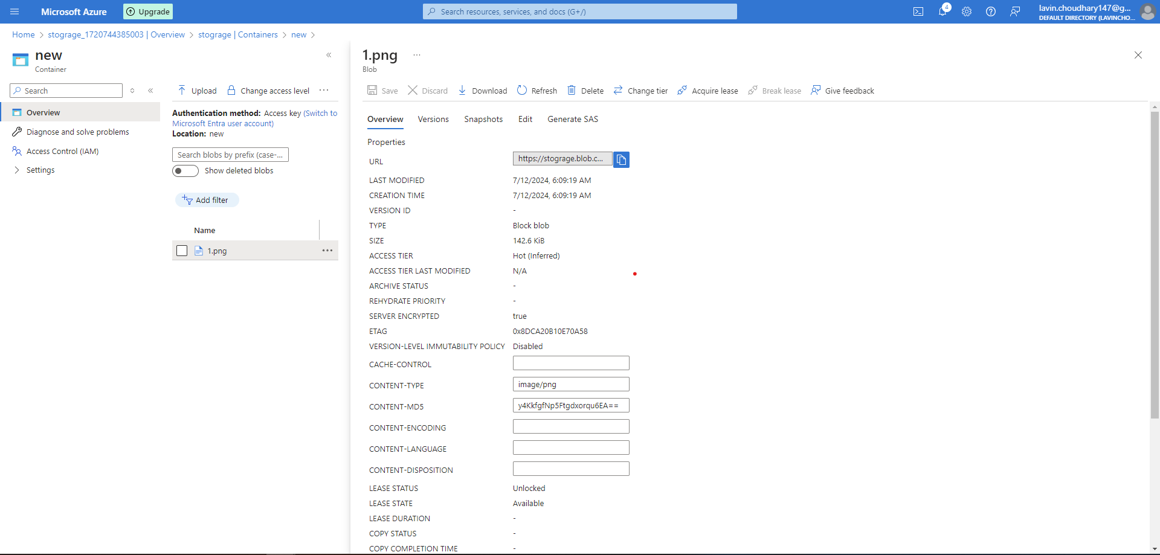

**Q :-** Try Azure storage explorer.

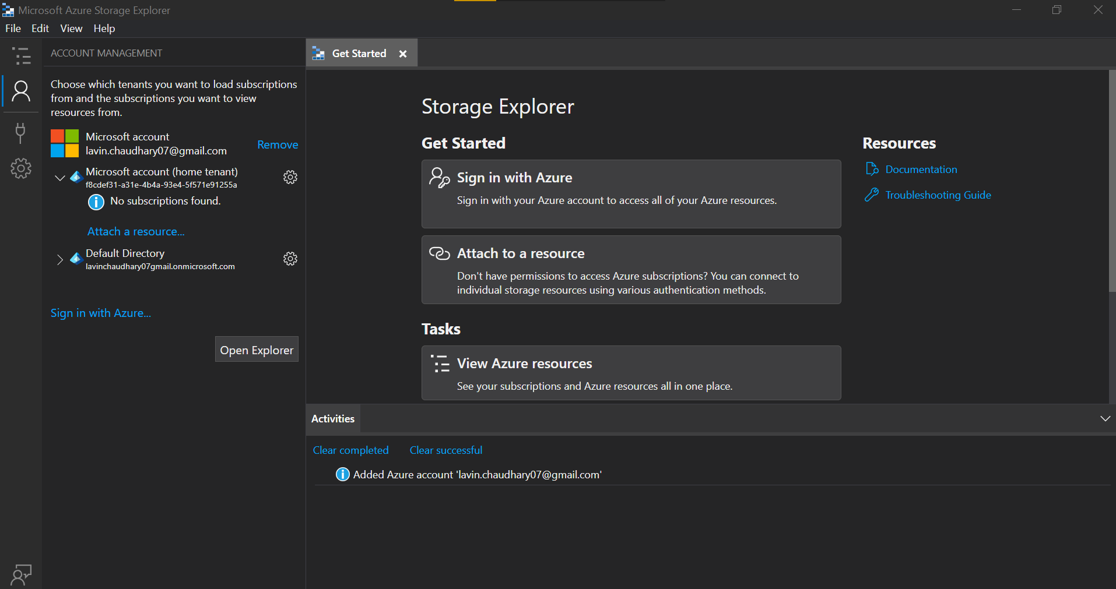

Q :- Provision Access keys and use them for connection with storage account.

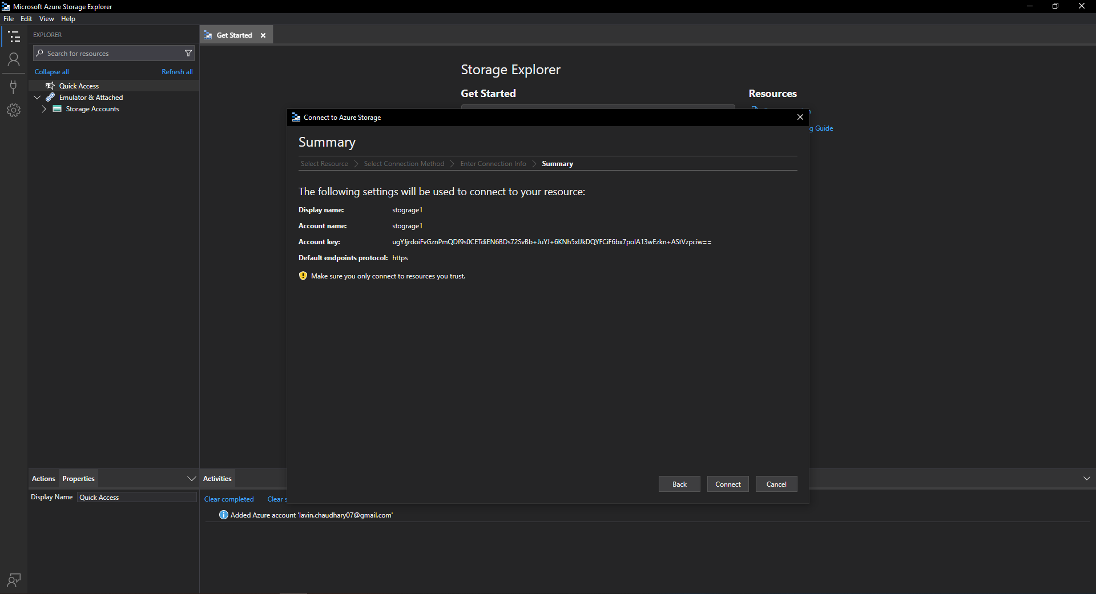

Q:- Create a Shared access signature and check access scope.

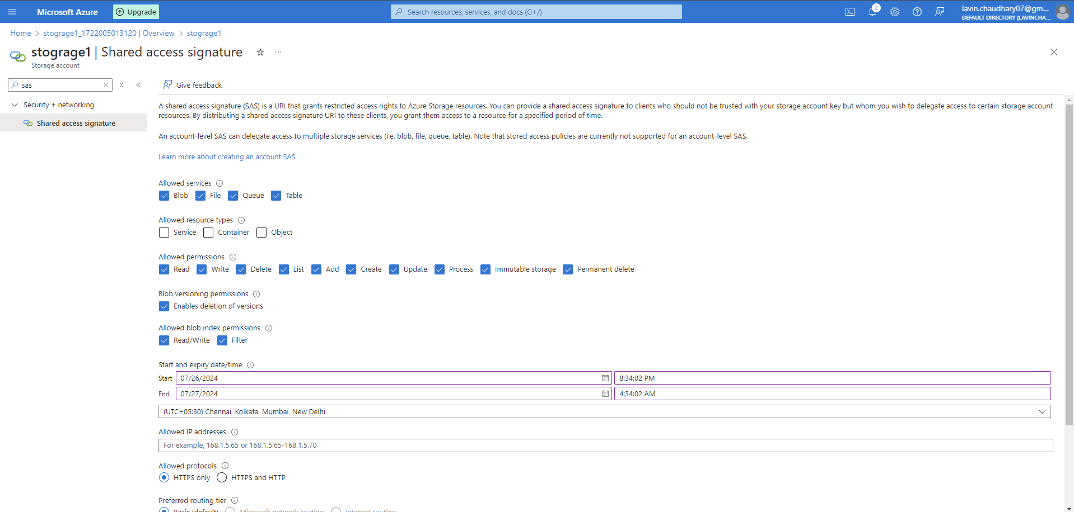

Q:- Create a stored access policy over shared access signature and check access scope.

